Making Inferences Planner Title: What can Video Games Teach Us?

Handout 4

CPQ: What are the pros about video games?



5

|  |  |  |  |  |
| --- | --- | --- | --- | --- |
| P# | Statement |  | Text Clues | Background Knowledge |
| 945  I do |  | * In the text   (direct)   * In my head (inference) | “A good video game is  challenging, entertaining, and complicated.” |  |
| 945  We do |  | * In the text   (direct)   * In my head (inference) | “Video games can enhance reading skills too” |  |
| 945  We do |  | * In the text   (direct)   * In my head (inference) | “Games can inspire new interests” |  |
| 946  You  Do  (TTT) |  | * In the text   (direct)   * In my head (inference) | “Video games might also help improve visual skills” |  |
| 946  You  Do  (TTT) |  | * In the text   (direct)   * In my head (inference) |  |  |

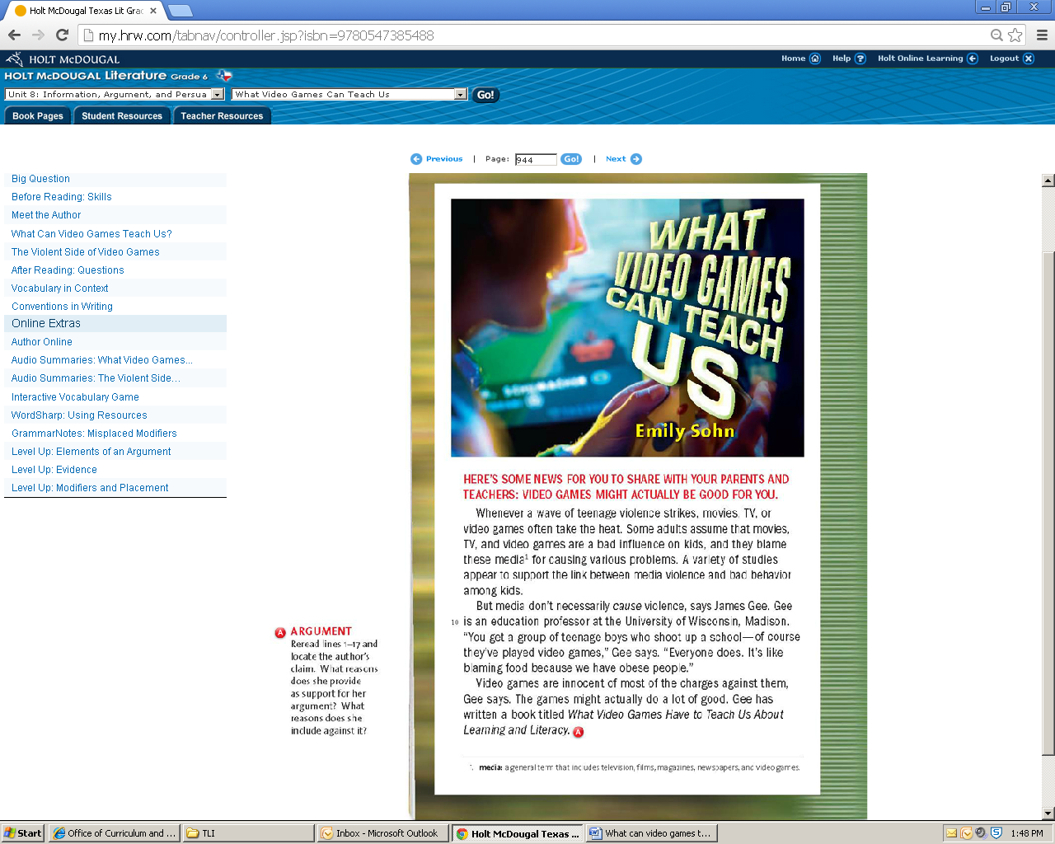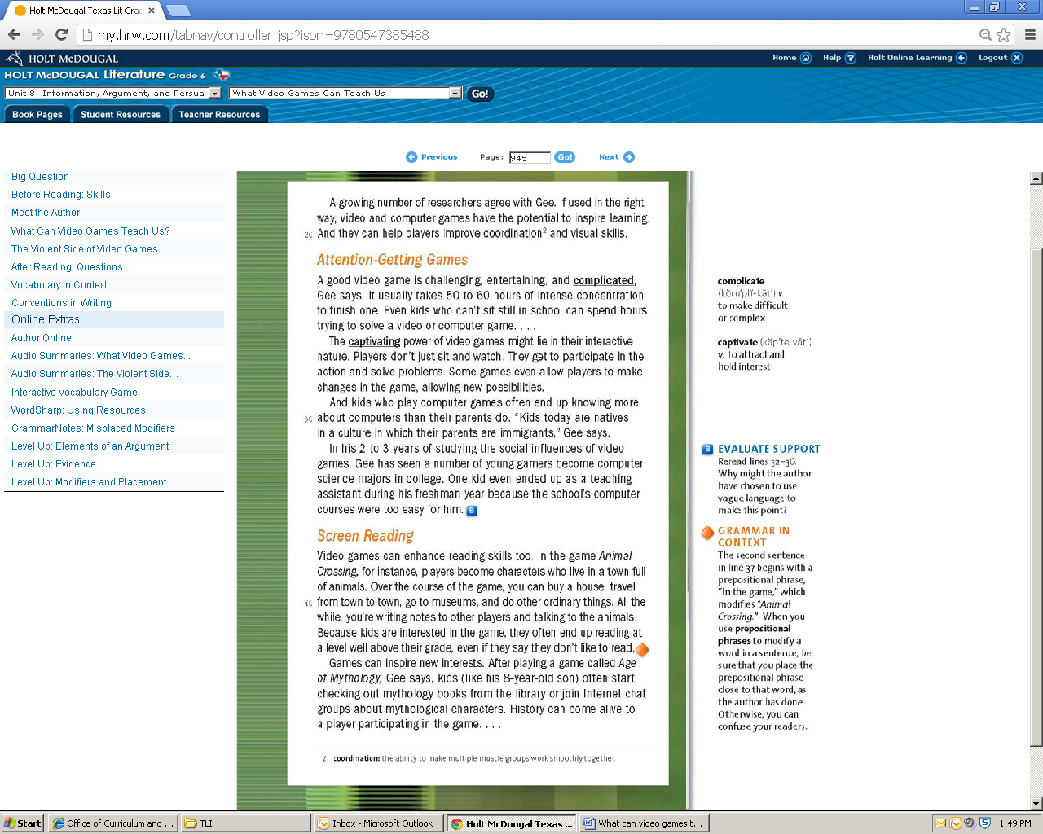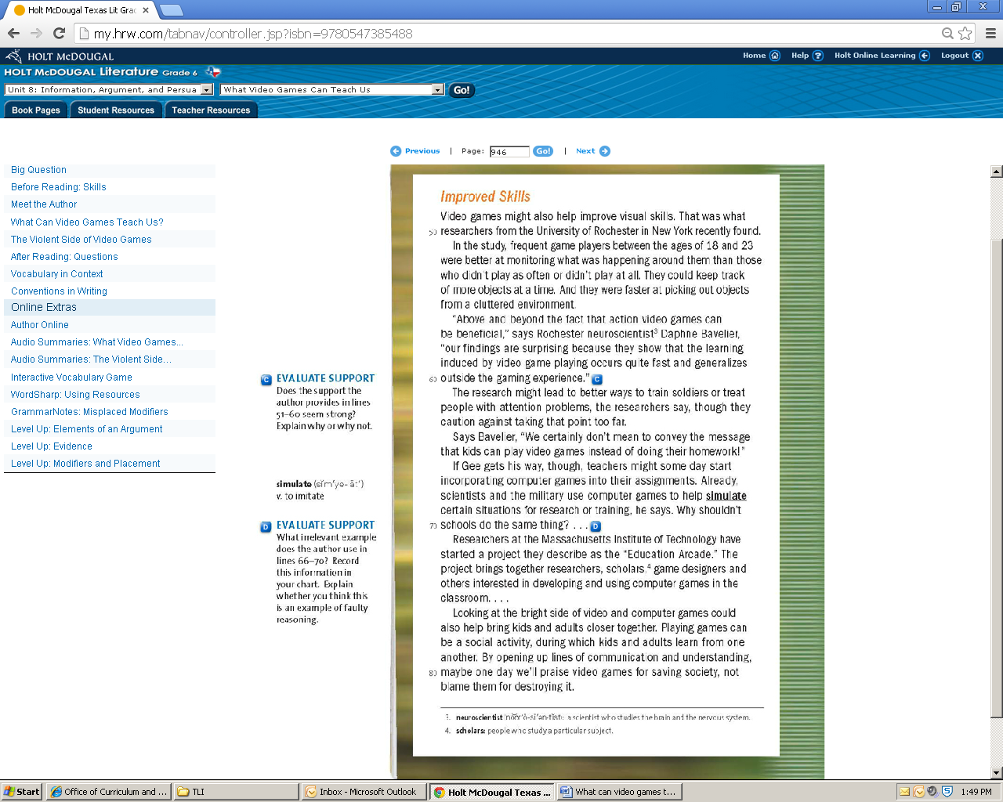

Making Inferences Planner Title: The Violent Side of Video Games

Handout 4

CPQ: What are the cons about video games?



5

|  |  |  |  |  |
| --- | --- | --- | --- | --- |
| P# | Statement |  | Text Clues | Background Knowledge |
| 947  I Do |  | * In the text   (direct)   * In my head (inference) | “…I started to think that looking at screens all the time might be affecting me in ways I didn’t even suspect.” |  |
| 947  We Do |  | * In the text   (direct)   * In my head (inference) | “Violence is one of the biggest concerns, especially as computer graphics and special effects become more realistic.” |  |
| 947  We Do |  | * In the text   (direct)   * In my head (inference) | “There’s also evidence that people become less sensitive to violence after awhile…” |  |
| 948  You Do  (TTT) |  | * In the text   (direct)   * In my head (inference) | “…mean world syndrome…” |  |
| 948  You Do  (TTT) |  | * In the text   (direct)   * In my head (inference) |  |  |

