Making Inferences Planner Title: Gombei and the Wild Ducks

Handout 4

CPQ: What is the topic in this folk tale?



5

|  |  |  |  |  |
| --- | --- | --- | --- | --- |
| P# | Statement |  | Text Clues | Background Knowledge |
| I do | Greedy | * In the text   (direct)   * In my head (inference) | “’Gombei’s father had said, ‘It would be too cruel to trap more than one at a time.” | I know that when I am able to have one and know it would be easy to get more I am tempted to try. |
| I do | Laziness | * In the text   (direct)   * In my head (inference) | “I am growing too old to work so hard.” | I know when I can have a lot at once, I’ll do it once in a larger quantity than many times and getting one per time. |
| We do | Laziness | * In the text   (direct)   * In my head (inference) | “I could loaf for ninety-nine days without working at all” | I know if I can do the work in one day, I’d rather do that then work everyday. |
| We do | The Golden Rule | * In the text   (direct)   * In my head (inference) | “He had been trapped like wild animal and soon he would be plucked and eaten.” | I know if I am put in a situation of getting hurt, I would not want to put someone else through that pain. |
| You do  (TTT) |  | * In the text   (direct)   * In my head (inference) | “’now I know how terrible it is for even one wild duck to be trapped and only this morning I was trying to trap a hundred poor birds. I am a wicked an greedy man,” |  |

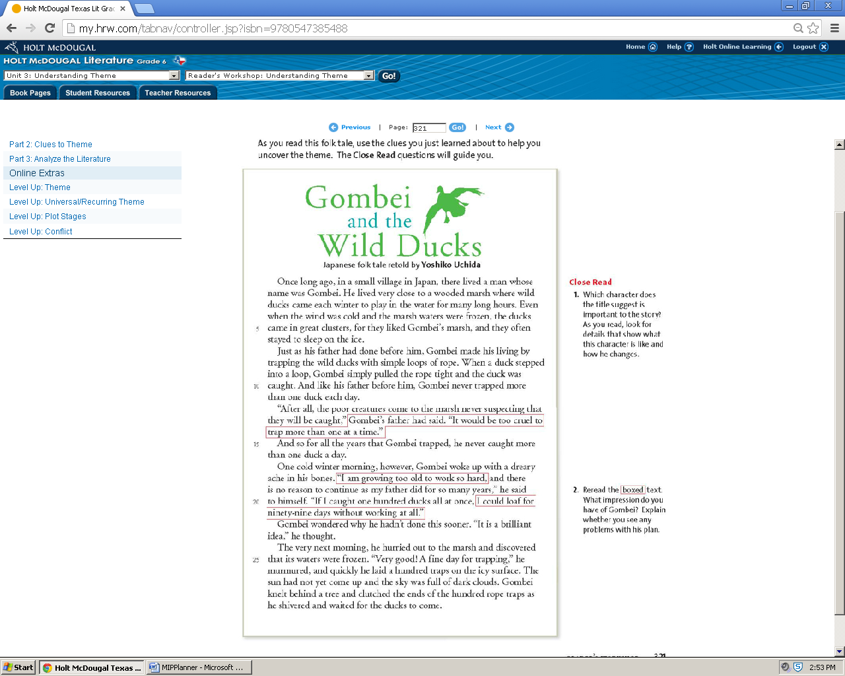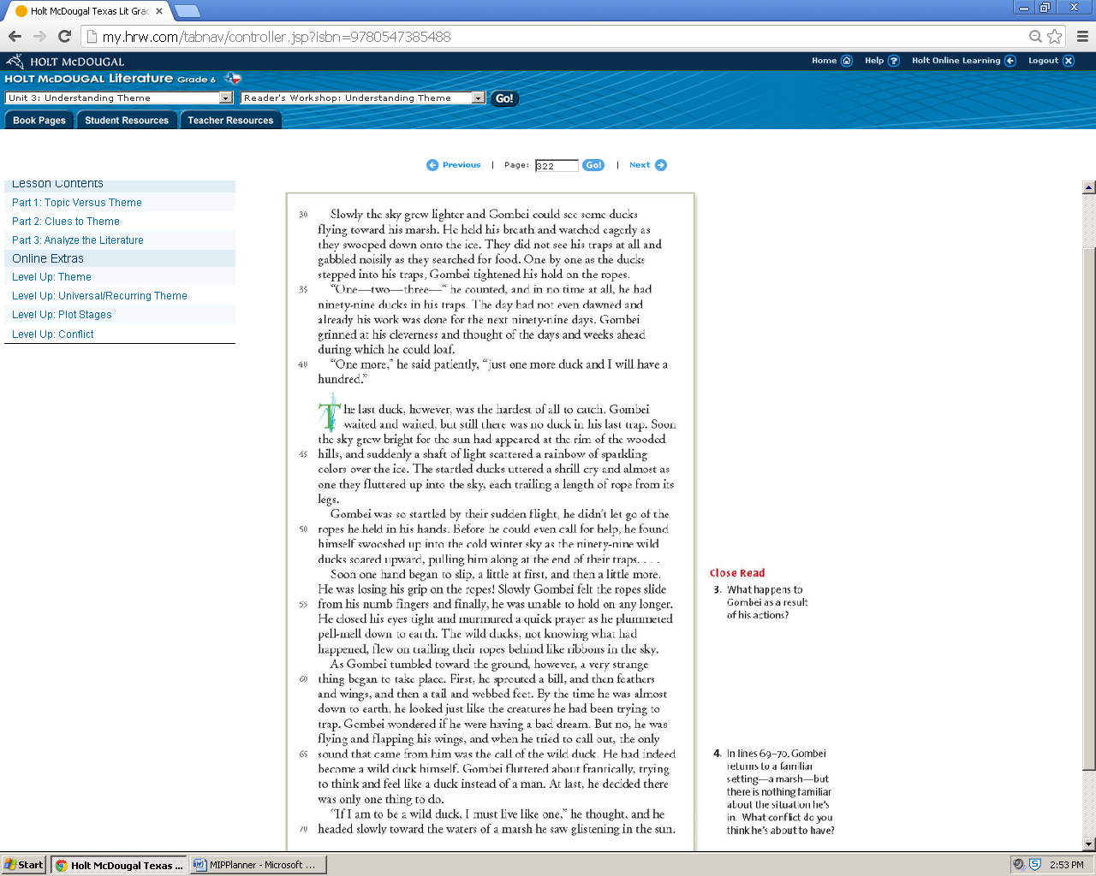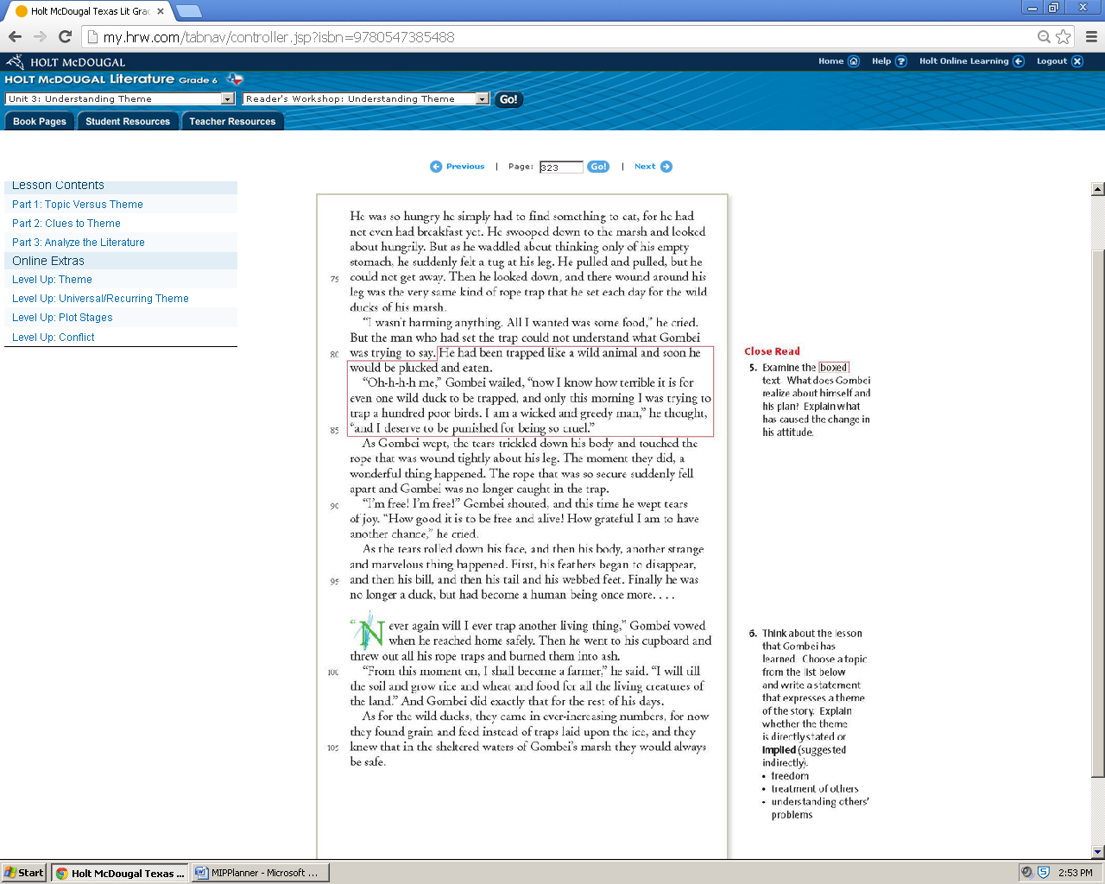

Making Inferences Planner Title: Gombei and the Wild Ducks

Handout 4

CPQ: What is the theme statement for this folk tale?



5

|  |  |  |  |  |
| --- | --- | --- | --- | --- |
| P# | Statement |  | Text Clues | Background Knowledge |
| I do | There is a sufficiency in the world for man's need but not for man's greed. | * In the text   (direct)   * In my head (inference) | “’Gombei’s father had said, ‘It would be too cruel to trap more than one at a time.” | I know that there are people who serve their plate with to much food and they end up throwing away the rest in the garbage. |
| we do | Laziness may appear attractive, but work gives satisfaction. | * In the text   (direct)   * In my head (inference) | “I am growing too old to work so hard. I could loaf for ninety-nine days without working at all” | Humans are made to work. When we get lazy we begin to become sad and depressed. |
| we do | Love other people as you would love yourself. | * In the text   (direct)   * In my head (inference) | “He had been trapped like wild animal and soon he would be plucked and eaten.” | I know if I’m not able to understand someone’s pain until I have been put in their place, I begin to understand how they feel. |
| you do | Love other people as you would love yourself. | * In the text   (direct)   * In my head (inference) | “’now I know how terrible it is for even one wild duck to be trapped and only this morning I was trying to trap a hundred poor birds. I am a wicked an greedy man,” | I know if I’m not able to understand someone’s pain until I have been put in their place, I begin to understand how they feel. |