Matter | State
Weight | Mass
Volume | Density
Magnetism | Conduction
Atom | Nucleus

form of matter (solid, liquid, or gas)  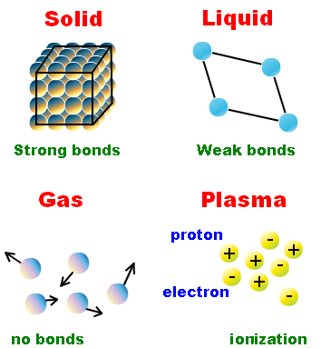 | anything that has mass and takes up space
amount of mass in an object (measured in grams)  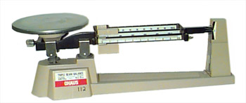 | amount of gravity pulling on an object  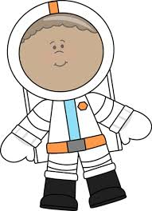
mass divided by volume (grams/liters)  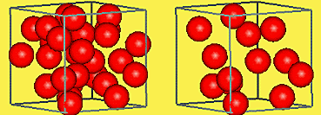 | amount of space an object takes up (measured in liters)  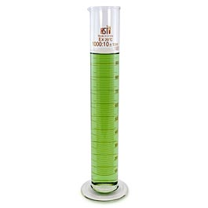
ability to carry heat, electricity, and sound (opposite of insulation)  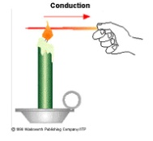 | ability to be pulled to a magnet  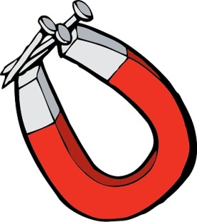
central part of an atom  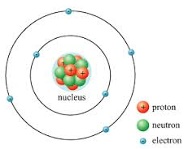 | smallest part of an element  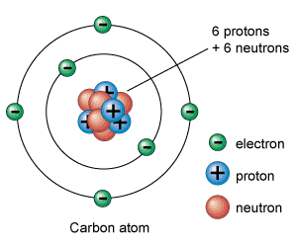
Proton | Neutron
Electron | Sea Breeze
Land Breeze | Law of Conservation of Mass
Physical Change | Chemical Change
Chemical Equation | Exothermic Reaction

no charge  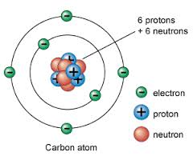 | + charge
daytime wind from ocean to land  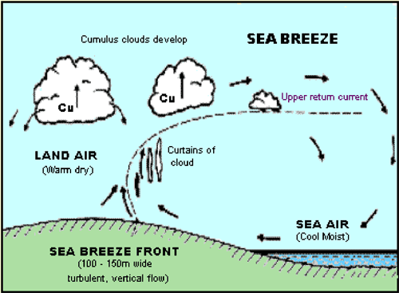 | - charge; located outside the nucleus
mass is not created or destroyed in an ordinary chemical reaction (total mass or reactants = total mass of products)  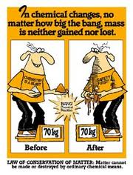 | nighttime wind from land to ocean  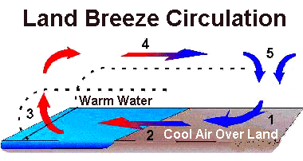
new substances are made when bonds between atoms are made/broken; often see color change, temperature change, gas or precipitate is formed example-rust forming | change in size, shape, or state; still same substance. example-tearing paper, steam an ice are both water
produces (gives off) energy  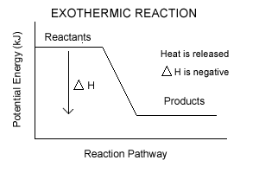 | gives the number & kind of substances in a reaction; number & type of atoms remain the same (balanced). Example - 2Na + Cl₂ 2NaCl (balanced) 2 atoms of Na and 2 atoms of chlorine on each side of equation  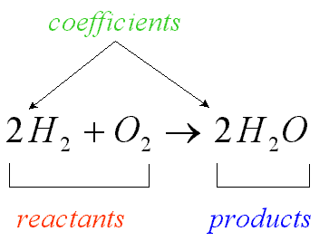
Endothermic Reaction | Metals
Nonmetals | Metalloids
Atomic Number | Atomic Mass
Symbol | Formula
Subscript | Periodic Table

-Left side of periodic table  -Shiny  -Can be bent or pulled  -Good conductors of heat & electricity  -Most are solids at room temperature  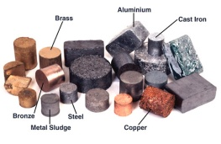 | absorbs (takes in) energy  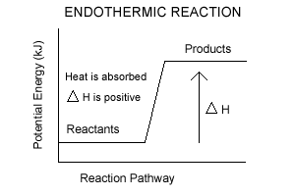
-Along stair step  -Conduct electricity under some conditions  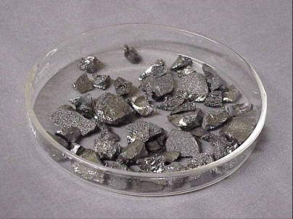 | -Right side of periodic table  -Mostly dull  -Brittle  -Poor conductors of heat & electricity  -Most are gases at room temperature  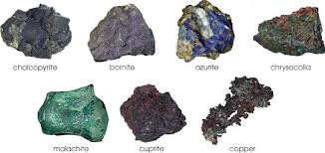
p + n  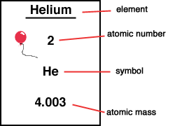 | protons
abbreviation of a substance  (Example – H₂O – water; NaCl – salt)  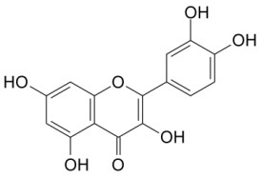 | abbreviation of an element;  First letter is capitalized, 2nd letter is lowercase  (Examples – H – hydrogen; Ag – Silver
a chart of all known elements  Arranged in rows increasing by the atomic number  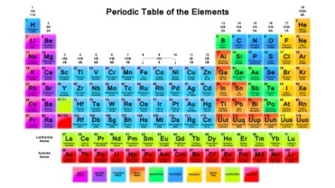 | # at the lower right of symbol;  shows number of atoms  (H₂O has 2 hydrogen atoms and one oxygen atom)  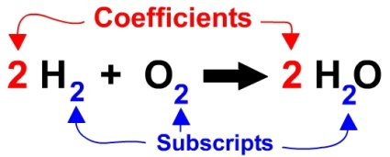
Solid | Liquid
Gas

-atomic movement (larger distances)  -Energy (medium)  -Shape (shape of container) | -atomic movement (small distances)  -energy (low)  -Shape (Fixed)
-atomic movement (Great distance)
-Energy (High)
-Shape (Fills space)

