Making Inferences Planner Title: Dangerous Threat? No-Loving Pet!

Handout 4

CPQ: What are the pro’s about owning a pit-bull?



5

|  |  |  |  |  |
| --- | --- | --- | --- | --- |
| P# | Statement |  | Text Clues | Background Knowledge |
| I DO | A pro is that I can cuddle up with a pit bull and it won’t bite me. | * In the text   (direct)   * In my head (inference) | “In fact they can make affectionate, loving, pets” | Usually when a dog is affectionate and loving I like to cuddly up with them. |
| I Do | I can rely on my pit bull to cheer me up when I’m having a bad day. | * In the text   (direct)   * In my head (inference) | “…but they have other qualities as well: loyalty, friendliness, and a desire to please” | Usually a friend is loyal, friendly and desires to please me. That friend is valuable when I’m having a bad day. |
| We do |  | * In the text   (direct)   * In my head (inference) | “…owners who treat pit bulls with love are rewarded with endless affection in return.” |  |
| We do |  | * In the text   (direct)   * In my head (inference) | “In one study, pit bulls got a better overall rating than golden retrievers, whom many people view as the friendliest dogs around.” |  |
| You do (TTT) |  | * In the text   (direct)   * In my head (inference) | “In reality, they don’t want to attack us; they want to curl up at our feet.” |  |

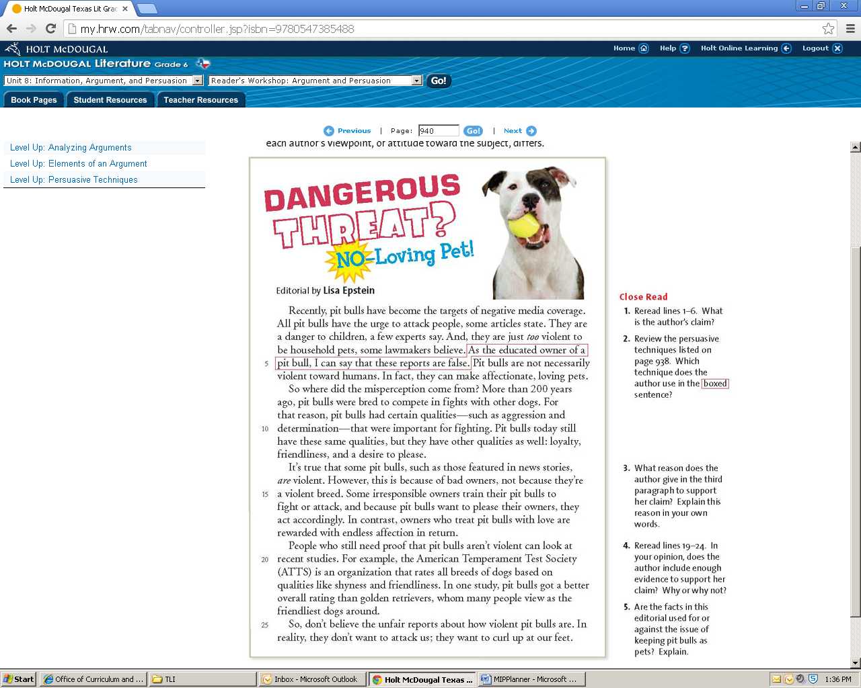

Creating Mental Images Title: Is This the Kind of Dog You want Roaming Our Streets?

Handout 4

CPQ: How does the text and image portray the pit-bull as a horrible dog to own?



5

|  |  |  |
| --- | --- | --- |
| P# | Text Clues | Created Mental Image |
| I do | The picture | I see…a dog snarling at me ready to bite my ankle while walking down the street. |
| We do | “Pit bulls are violent creatures, capable of biting and attacking innocent children.” | I see…a pitbull attacking a harmless 5 year old girl that is sitting down playing with her Barbie doll. |
| You do | The picture (splattered yellow paint) | I feel…destruction when I see the yellow spots of paint and that dog is about to destroy someone’s day. |
|  |  |  |
|  |  |  |

