Making Inferences Planner Title: Chapter 9 The Cell

Handout 4

CPQ: What are the functions of the different types of cells?



5

|  |  |  |  |  |
| --- | --- | --- | --- | --- |
| P# | Statement |  | Text Clues | Background Knowledge |
| 104 I do | Bacteria is a simple type of cell | * In the text   (direct)   * In my head (inference) | “Bacteria are the simplest types of cells.” |  |
| 105 I do | Cell membrane functions to hold things together and let things enter and exit. | * In the text   (direct)   * In my head (inference) | “Cell Membrane. Each cell is covered by a thin membrane of specialized molecules. The cell membrane holds the cell together. It also controls what enters and leaves the cell.” | I know on tv shows when they insert different chemicals into a cell there is an outer line that is punctured. This must be the cell membrane. |
| 106 We do | The nucleus functions as the cell’s DNA and holds information to make more similar cells. | * In the text   (direct)   * In my head (inference) | “Nucleus. A large nucleus near the center of the cell holds the cell’s DNA, its hereditary information.” | I know when forming life you need DNA from both the Mom and the Dad. From that new information a baby is formed. |
|  |  | * In the text   (direct)   * In my head (inference) |  |  |
|  |  | * In the text   (direct)   * In my head (inference) |  |  |

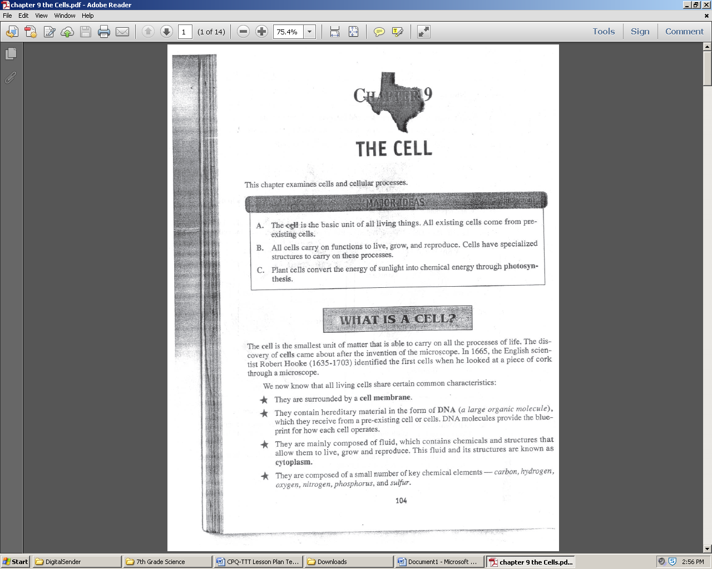 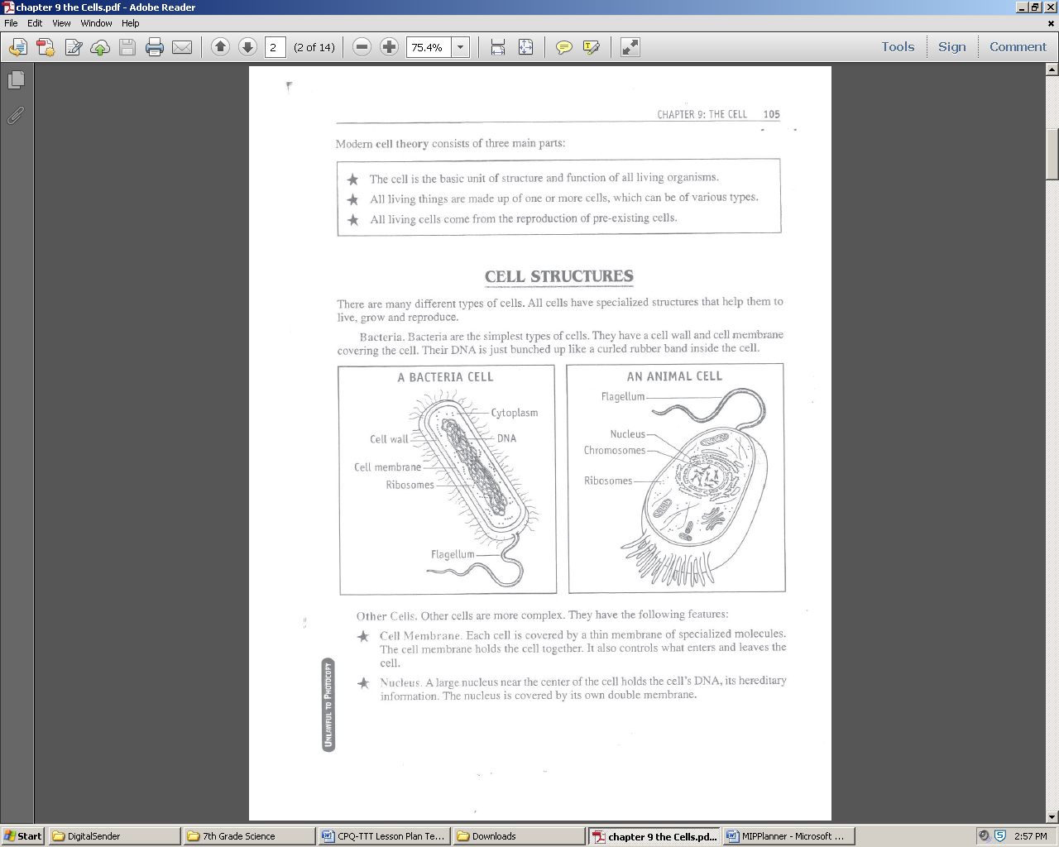 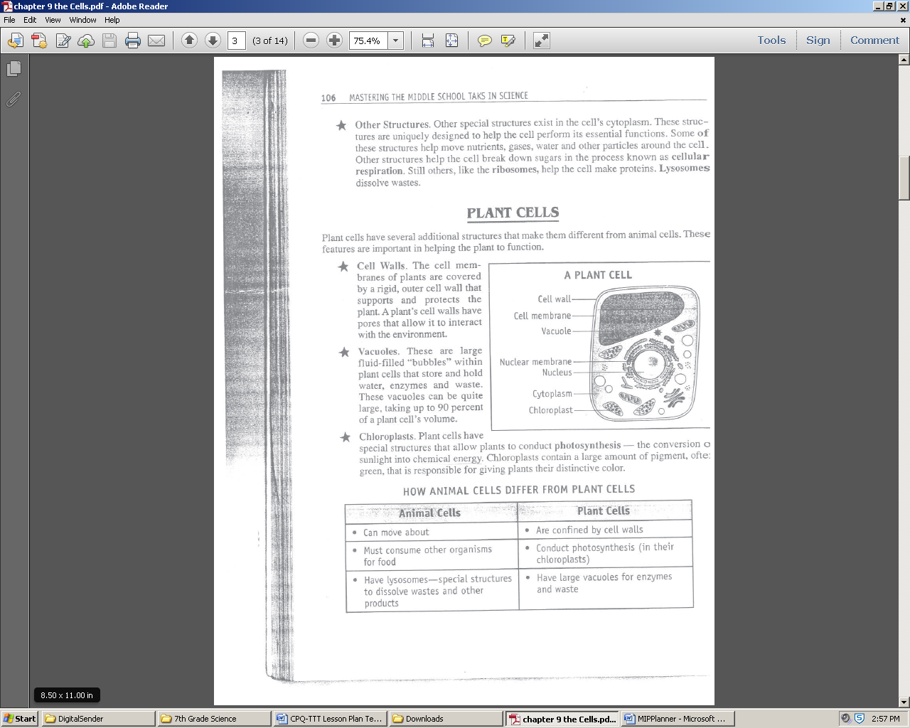 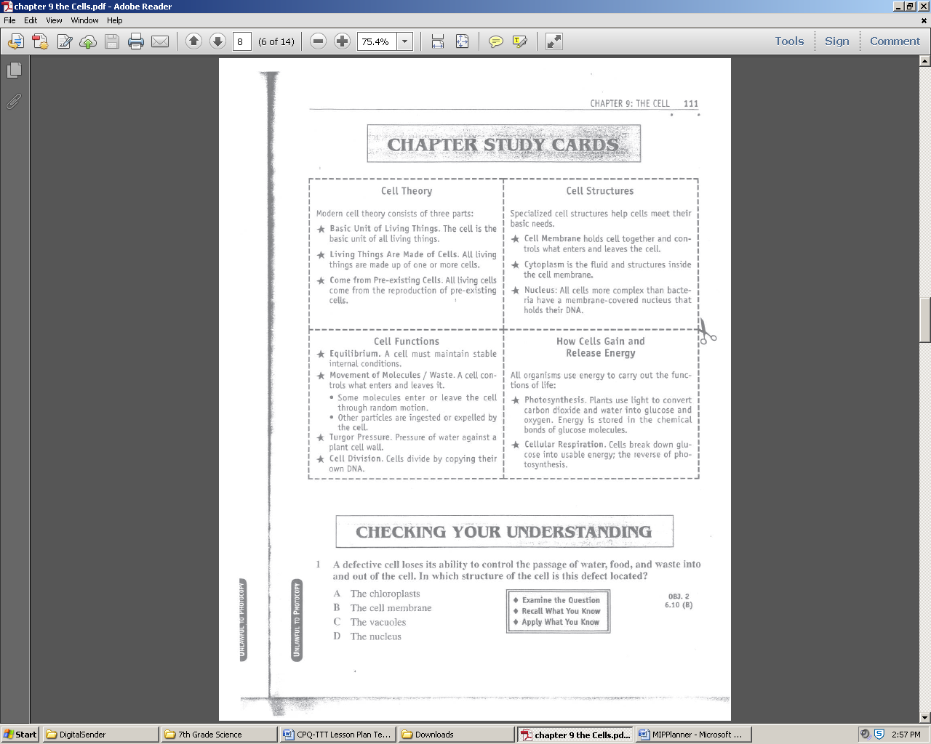 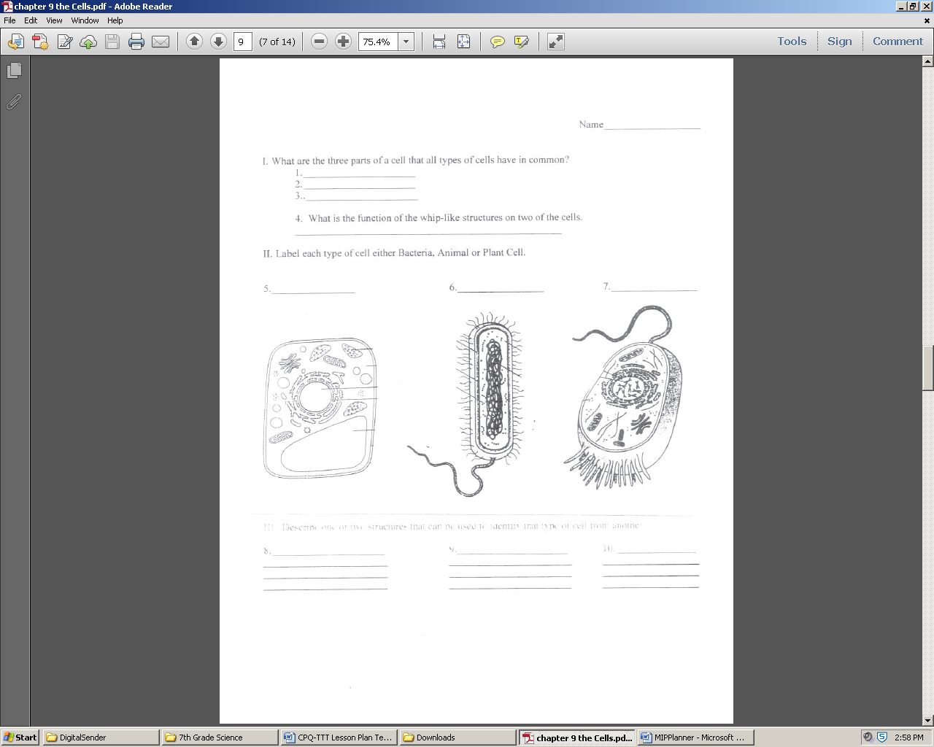 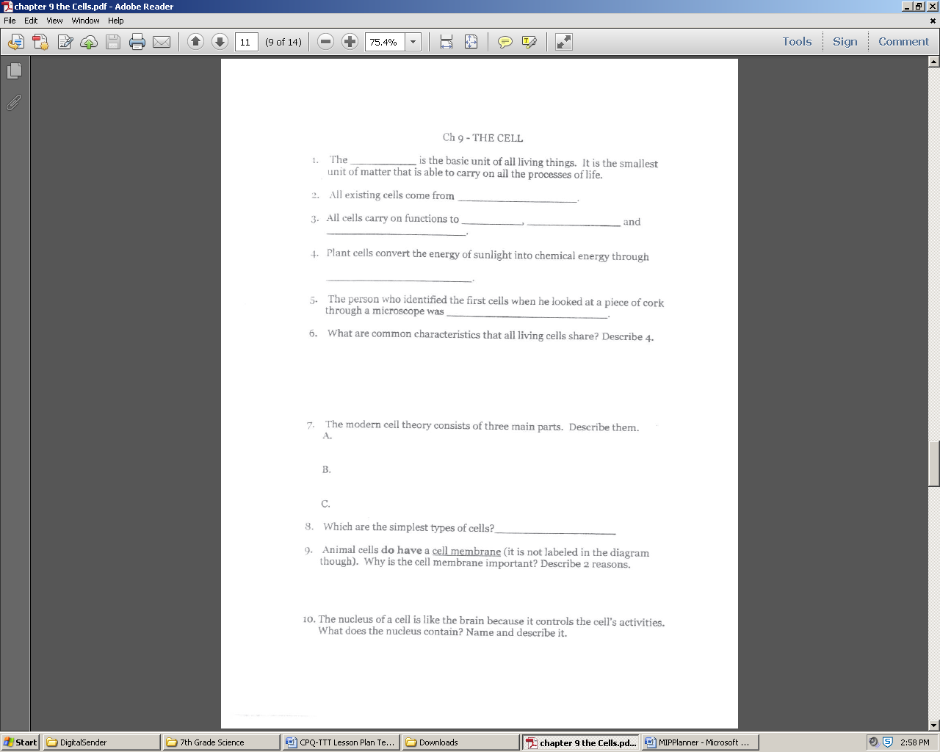 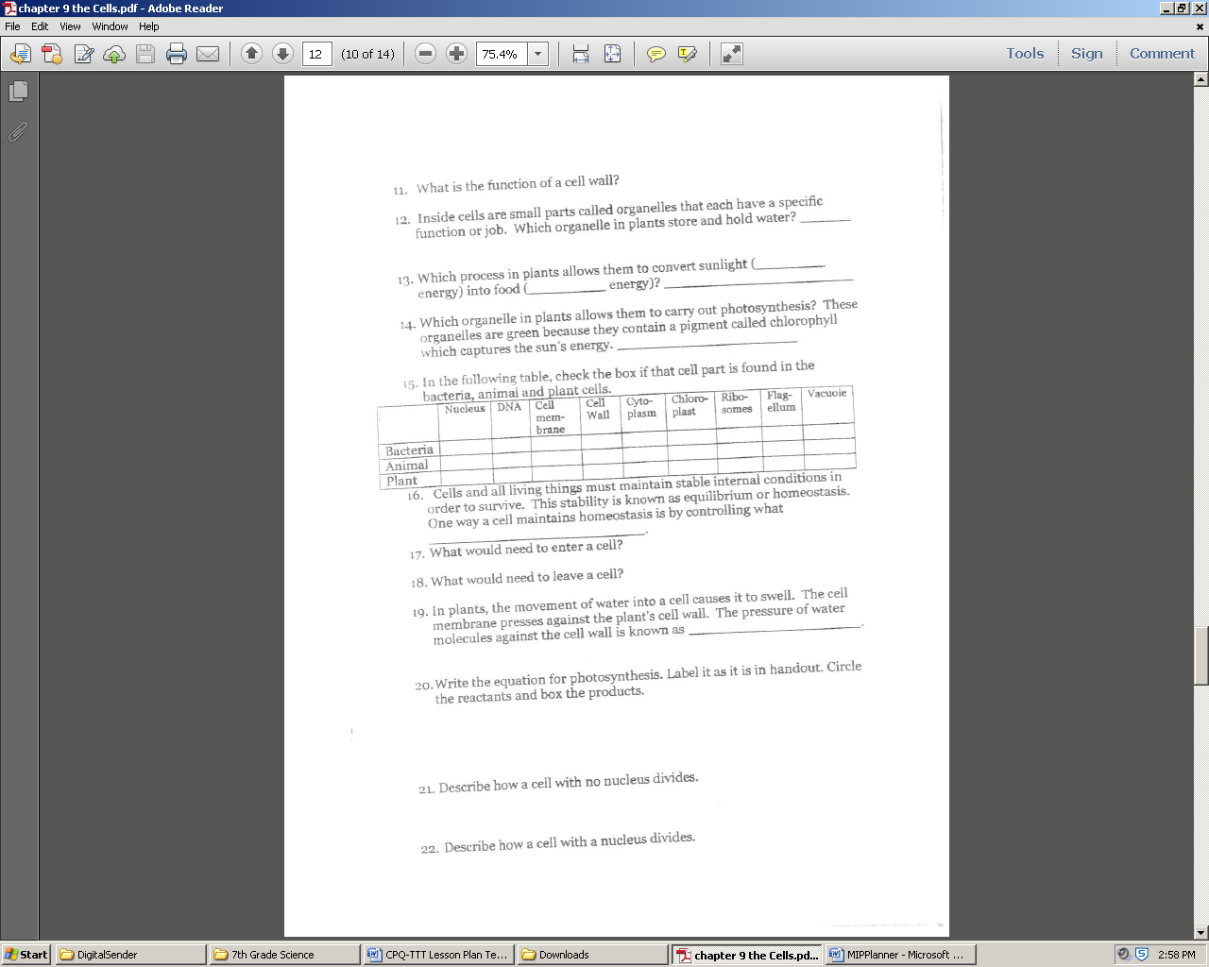 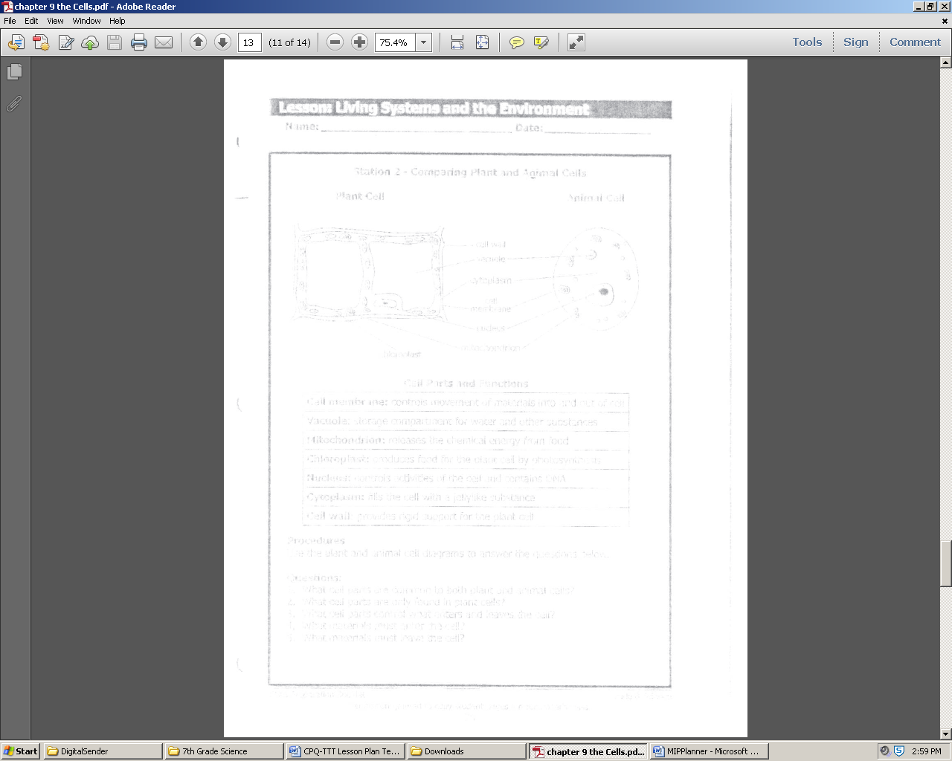 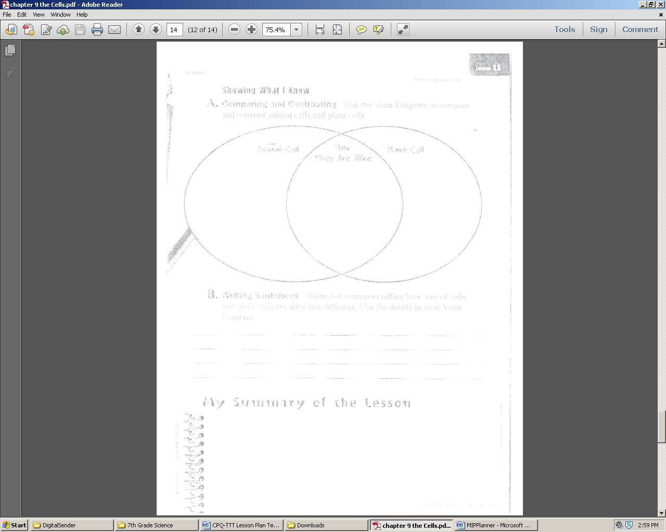 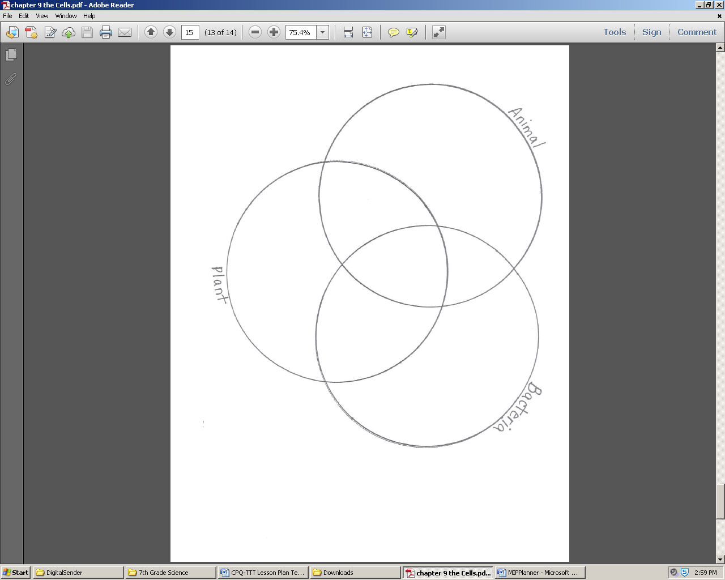

CPQ: What are some differences between plant and animal cells?